Bloomberg - https://www.bloomberg.com/graphics/2017-value-of-life/

No One Values Your Life More
Than the Federal Government

By Dave Merrill
October 19, 2017

When a federal agency wants to implement a new regulation, it often needs to answer one basic question first: Do the benefits outweigh the costs? One way of calculating how beneficial a regulation might be is to measure how many deaths it would prevent, and what each life saved is worth.

Some federal agencies have decided that your life is exceedingly valuable. While the average U.S. household has a net worth of less than $100,000, the Environmental Protection Agency pegs the value of one life at about $10 million, one of the highest among federal agencies.

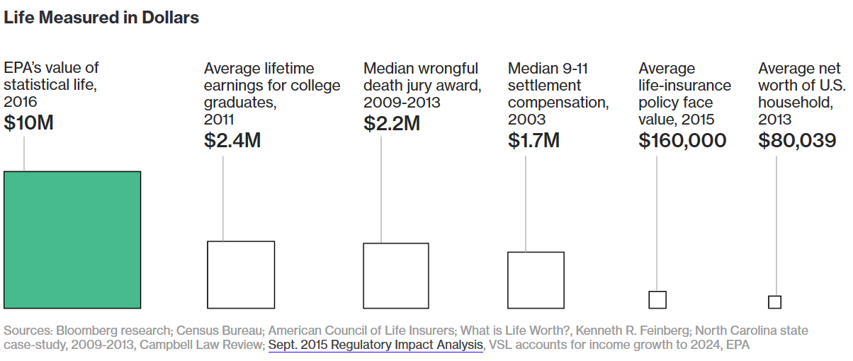

Not every regulation depends on a value of statistical life, or VSL, to calculate its benefits. And while a proposed rule is not required to pass a cost-benefit analysis, it has a much better chance of going into effect if it does. Typically, VSLs are cited in no more than a dozen rules in a given year. But these “major rules” by definition have a significant economic impact.

When the VSL is used, it has proven to be a valuable benchmark in offsetting anticipated costs of a regulation. And over time, as wages and the public’s willingness to pay for safety measures have grown, agencies have dramatically increased what they think a life is worth.

Agencies Agree on One Thing: The Value of Life is Going Up

Adjusted for inflation, the VSL used by major U.S. regulatory agencies has risen dramatically.

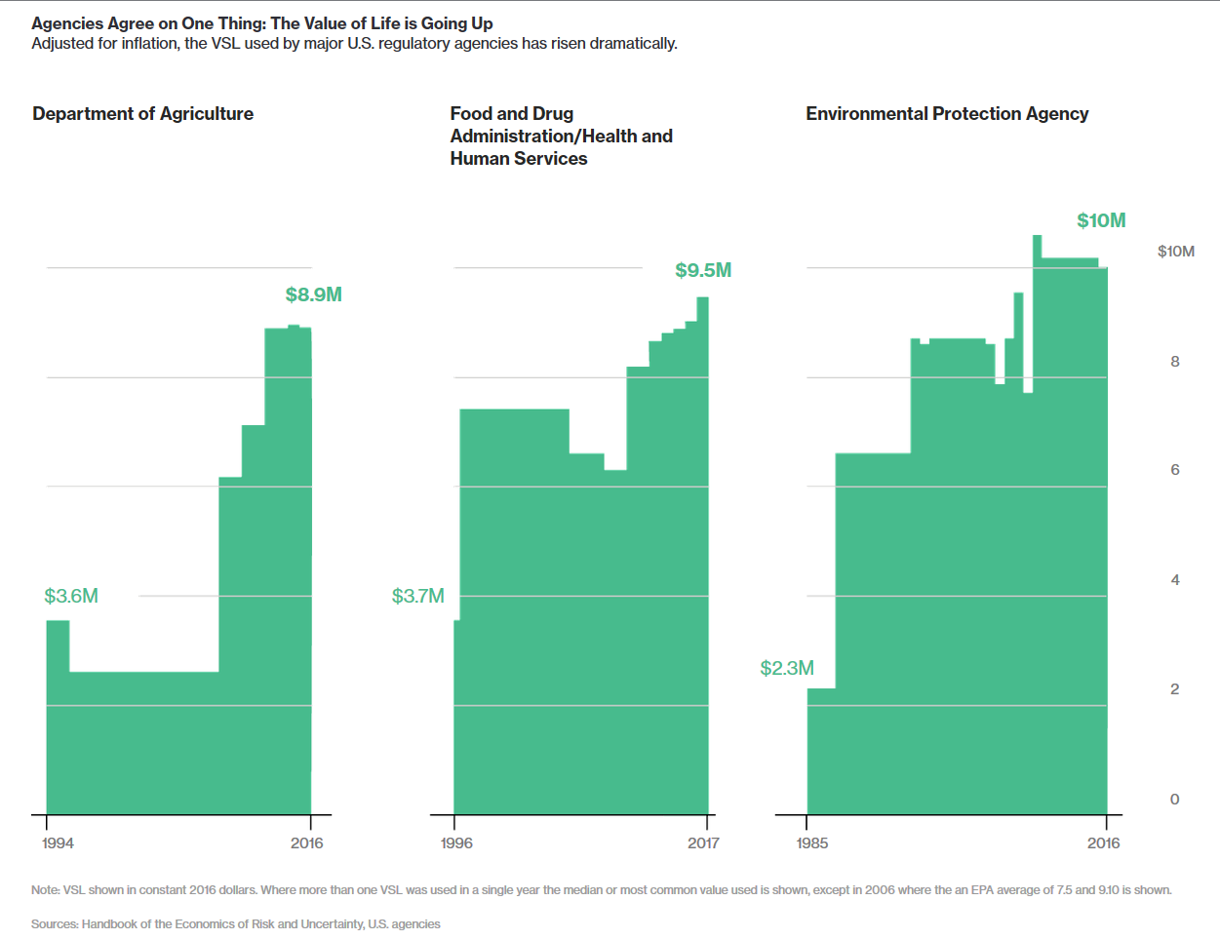

Note: VSL shown in constant 2016 dollars. Where more than one VSL was used in a single year the median or most common value used is shown, except in 2006 where the an EPA average of 7.5 and 9.10 is shown.

Sources: Handbook of the Economics of Risk and Uncertainty, U.S. agencies

While agencies calculate their VSL based on scientific studies (the EPA consults 26 that recommend VSLs ranging from $1 million to $24.5 million), the math can be subject to interpretation.

The Trump administration has rolled back dozens of regulations put in place by President Barack Obama, citing cost projections it says were too low or benefits that were inflated.

Last week, EPA Administrator Scott Pruitt began the process of repealing the Clean Power Plan, a regulation that placed limits on greenhouse gas emissions from power plants. He disputed, in part, $55 billion to $93 billion in estimated health and live-saving benefits the agency had calculated under Obama as justification for the rule. And when the Trump administration ran its own math, it said the regulation would cost as much as $33 billion, compared to $8 billion calculated under the Obama administration.

It’s not just political interpretation that can alter the fate of a regulation. As VSLs have increased, once marginally beneficial safety measures can suddenly yield benefits far in excess of costs—meaning proposed regulations left for dead can have new life.

In 2007, the Department of Transportation was petitioned to consider a rule that would force automakers to install rear seat belt reminder systems in every car. The agency estimates the rule will save at least 44 lives each year and cost the auto industry up to $325 million annually. Considering the Department of Transportation’s inflation-adjusted VSL of $6.4 million in 2008, the regulation’s high-end cost estimate at the time of the petition exceeded low-end benefits.

The agency is still considering the rule. But now, its VSL has ballooned to $9.6 million. So assuming similar estimates to lives saved and costs to automakers, the rule’s benefits now far exceed their costs.

Benefiting From a Higher VSL

Using a $9.6 million value of statistical life, the estimated benefits of a proposed seat belt reminder system outweigh the $324.6 million high-end costs that would be imposed on car manufacturers.

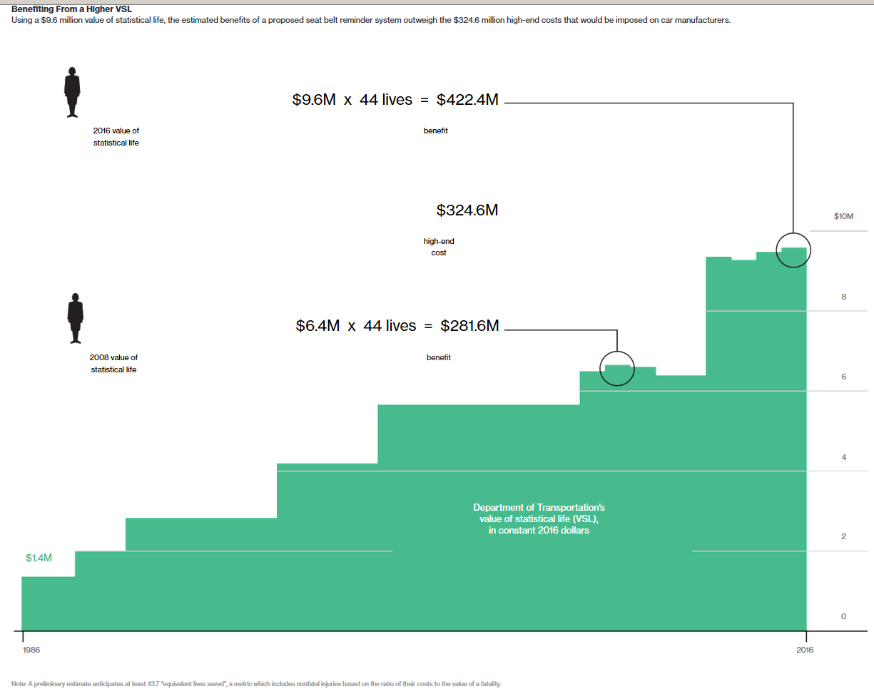
Note: A preliminary estimate anticipates at least 43.7 “equivalent lives saved”, a metric which includes nonfatal injuries based on the ratio of their costs to the value of a fatality.
Sources: Bloomberg analysis, Handbook of the Economics of Risk and Uncertainty, Department of Transportation
Are federal agency estimations of the value of life correct? Some say no.

In a study published in March, the libertarian think-tank Strata suggests that the VSL may be several millions of dollars too high. Study co-author Ryan Bosworth, professor of applied economics at Utah State, says people do a bad job calculating risk trade-offs.

“A couple will pay a premium for an infant car safety seat engineered with titanium, then drive with reckless abandon,” Bosworth said. “They’re not getting a lot of bang for their buck.”

Richard Thaler, winner of the 2017 Nobel Prize in Economics, similarly calculated a much lower estimate for human life. His wage studies, which are used by federal agencies as the most common way of estimating VSL, calculated how much more a worker would expect to be paid to assume a risk. The size of the worker pool at risk for one annual death multiplied by the amount of extra wages equals the VSL. In 1976, Thaler calculated the value of life at approximately $200,000 in 1967 dollars, or $1.5 million in today’s dollars.

The Science of Valuing Life

Scientists look at market forces to estimate a value of statistical life. Dangerous jobs are compensated based on a degree of risk. In this hypothetical example, if a miner faces an additional 1-in-5,000 chance of death compared to similar jobs, then the total extra wages paid equals the VSL.

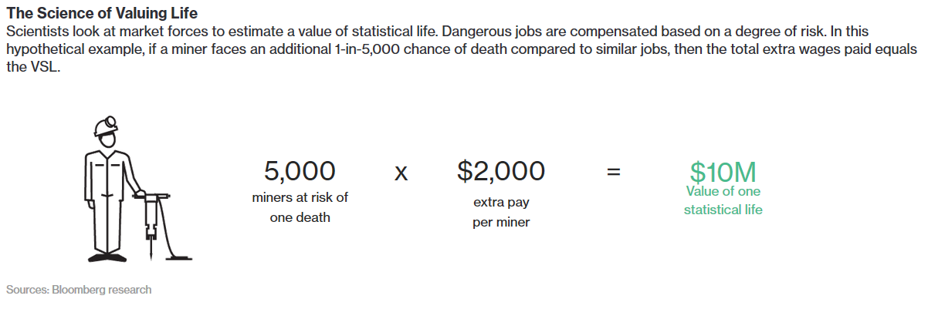Sources: Bloomberg research

It’s doubtful agencies would be willing to make such drastic reductions to their VSLs. The Office of Management and Budget has generally endorsed agency VSLs as high as $10 million, though it hasn’t set a single government-wide VSL.

According to W. Kip Viscusi, professor of law and economics at Vanderbilt University, the EPA tried to adjust life values downward in 2003—igniting a political firestorm. In preparing an analysis for the Clear Skies Initiative, the agency applied a 37 percent lower life value for people 65 and older. The EPA quickly abandoned what became known as the “senior discount.”

Viscusi, whose research has become the foundation of modern agency VSLs, says that so far, the Trump administration hasn’t taken steps to lower the VSL.

“Lowering the VSL is not likely something that they will change. All hell broke loose when the EPA tried to lower it," said Viscusi. "It’s going nowhere but up.”

* * * * * * * * * * * *

Economy https://www.nytimes.com/pages/business/economy/index.html

As U.S. Agencies Put More Value on a Life, Businesses Fret
By BINYAMIN APPELBAUMFEB. 16, 2011

Testing a G.M. vehicle. The Transportation Department says each life saved is worth $6 million. Credit Paul Sancya/Associated Press

WASHINGTON — As the players here remake the nation’s vast regulatory system, they have been grappling with a subject that is more the province of poets and philosophers than bureaucrats: what is the value of a human life?

The answer determines how much spending the government should require to prevent a single death.

To protests from business and praise from unions, environmentalists and consumer groups, one agency after another has ratcheted up the price of life, justifying tougher — and more costly — standards.

The Environmental Protection Agency set the value of a life at $9.1 million last year in proposing tighter restrictions on air pollution. The agency used numbers as low as $6.8 million during the George W. Bush administration.

The Food and Drug Administration declared that life was worth $7.9 million last year, up from $5 million in 2008, in proposing warning labels on cigarette packages featuring images of cancer victims.

The Transportation Department has used values of around $6 million to justify recent decisions to impose regulations that the Bush administration had rejected as too expensive, like requiring stronger roofs on cars.

And the numbers may keep climbing. In December, the E.P.A. said it might set the value of preventing cancer deaths 50 percent higher than other deaths, because cancer kills slowly. A report last year financed by the Department of Homeland Security suggested that the value of preventing deaths from terrorism might be 100 percent higher than other deaths.

The trend is a sensitive subject for an administration that is trying to improve its relationship with the business community, much of which has bitterly opposed the expansion of regulation. The White House said the decisions on the value of life were made by the agencies. The agencies, for their part, referred any questions to the White House.

“This administration utilizes the best available science in assessing the benefits and costs of any potential regulation, drawing on widely accepted methodologies that have been in use for years,” Meg Reilly, a spokeswoman for the Office of Management and Budget, which oversees the rule-making process, said in an e-mail.

Several independent experts, however, said that the increases were long overdue, noting that some agencies had been using the same values for more than a decade without adjusting for inflation. One office at the E.P.A. cut the value of life in 2004.

“Agencies have been using numbers that I thought were just too low,” said W. Kip Viscusi, a professor of economics at Vanderbilt University whose research is cited by most of the federal agencies as the basis for their calculations.

Businesses would prefer to discuss the consequences of the increases — new regulations and higher costs, which they say are hampering economic growth — rather than suggest that the government has overstated the value of life.

But some industry representatives said assigning a value to life was inherently subjective, and that the recent changes were driven by the administration’s pursuit of its regulatory agenda rather than scientific considerations.

“It looks like they just cooked the books — they just doubled the numbers,” said Todd Spencer, executive vice president of the Owner-Operator Independent Drivers Association, a trade group for the trucking industry, which faces higher costs under some of the Transportation Department’s new rules. The Bush administration rejected a plan in 2005 to make car companies double the roof strength of new vehicles, which it estimated might prevent 135 deaths in rollover accidents each year.

At the time, Transportation officials figured that the cost of the roofs would exceed the value of lives saved by almost $800 million. So the agency proposed a smaller increase in roof strength that might save 44 lives a year.

Last year, the Obama administration imposed the stricter and more expensive roof-strength standard, and it published a new set of calculations showing that the benefits outstripped the costs.

Most of the difference came from the increased value of human life. By raising that number to $6.1 million from a figure of $3.5 million in the original study, the Obama administration rendered those 135 lives — and hundreds of averted injuries — more valuable than the roofs.

The pattern of increases is scrambling a long-standing political dynamic. The business community historically has pushed for regulators to put a dollar value on life, part of a broader campaign to make agencies prove that the benefits of proposed regulations exceed the costs.

But some business groups are reconsidering the effectiveness of cost-benefit analysis as a check on regulations. The United States Chamber of Commerce is now campaigning for Congress to assert greater control over the rule-making process, reflecting a judgment that formulas may offer less reliable protection than politicians.

Some consumer groups, meanwhile, find themselves cheering the government’s results but reluctant to embrace the method. Advocates for increased regulation have long argued that cost-benefit analysis understates both the value of life and the benefits of government oversight.

“If analysis is going to be imposed on the rule-making process, we want higher values for injury and for fatalities,” said Robert Weissman, president of Public Citizen, which pushed the Transportation Department to reconsider the roof-strength regulation.

But Mr. Weissman said he still believed that such analysis was an impediment to necessary regulation.

“The bigger picture is absent,” he said. “How do you do cost-benefit analysis on global warming? It constrains the imagination. It really is a constraint in terms of bounding what is given serious consideration.”

The current rise in the value of life is based on the work of Professor Viscusi, who wrote his first paper on cost-benefit analysis as a Harvard undergraduate in the early 1970s. He won a prize and found a career.

The idea he and others have since developed in a long string of studies is that differences in wages show the value that workers place on avoiding the risk of death. Say that companies must pay lumberjacks an additional $1,000 a year to perform work that generally kills one in 1,000 workers. It follows that most Americans would forgo $1,000 a year to avoid that risk — and that 1,000 Americans will collectively forgo $1 million to avoid the same risk entirely. That number is said to be the “statistical value of life.”

Professor Viscusi’s work pegs it at around $8.7 million in current dollars.

Before the current administration, only the E.P.A. had fully embraced this methodology. Other agencies relied instead on the results of surveys asking Americans how much they would spend to avoid a given risk. This technique tends to produce significantly lower results. An even older technique, which yields even lower numbers, is to sum the wages lost when a worker dies. In 2000 the E.P.A set a baseline of $7.8 million, updated to current dollars. But in 2004, the office that issues clean air regulations reduced that baseline by $500,000 in an analysis of proposed limits on emissions from industrial boilers.

Last year, the E.P.A. directed its various offices to return to the 2000 baseline, adjusting that figure for inflation and wage growth. In some recent studies, the E.P.A. has used a figure of $9.1 million after making those adjustments.

The agency said at the same time that it was working to set a new standard. In a white paper issued in December, it raised the possibility that people might place a higher value on avoiding a slow death from cancer than a quick death in a car accident. It also broached a concept it described as “altruism,” the idea that people may place a higher value on the common good than on their own survival.

John D. Graham, who oversaw the use of cost-benefit analysis during the George W. Bush administration, said that the scientific justification was “quite strong” for raising the values used by the Transportation Department, but he cautioned that the E.P.A. was going too far.

“Why should the same clinical condition be valued differently at different federal agencies?” Mr. Graham, now dean of the School of Environmental and Public Affairs at Indiana University, asked in an e-mailed response to questions.

Many experts similarly ask why life itself should be valued differently. Agencies are allowed to set their own numbers. The E.P.A. and the Transportation Department use numbers that are $3 million apart. The process generally involves experts, but the decisions ultimately are made by political appointees.

The Office of Management and Budget told agencies in 2004 that they should pick a number between $1 million and $10 million. That guidance remains in effect, although the office has more recently warned agencies that it would be difficult to justify the use of numbers under $5 million, two administration officials said.

Close observers of the process point to two reasons for the variation in numbers. First, they say that setting a single standard is not worth the high-stakes battle that would be required with advocates on both sides. The Obama administration, like its predecessors, has preferred to deal with the issue informally, on an agency-by-agency basis.

Second, they say the lack of a standard preserves flexibility.

The Food and Drug Administration issued a rule in 2009 requiring new warning labels on packages and bottles of acetaminophen and other drugs. Its justification valued life at $5 million. A few months later, the agency acknowledged that it had calculated the cost of adding one new label, while requiring two new labels. However, the agency continued, the benefits still exceeded the costs because the value of life was $7 million.

A few months later, in an unrelated rule regarding salmonella, the agency once again cited a value of $5 million, which it said best reflected the available research. And in its recent study on cigarette labels, the agency cited a value of $7.9 million.

“The reality is that politics frequently trumps economics,” said Robert Hahn, a leading scholar of the American regulatory process who is now a professor at the University of Manchester in England. But he said that putting a price tag on life still was worthwhile, to help politicians choose among priorities and to shape the details of their proposals.

“Even small changes,” he said, “can save billions of dollars.”

A version of this article appears in print on February 17, 2011, on Page A1 of the New York edition with the headline: A Life’s Value?

* * * * * * * * * * * *

From the Office of Management and Budget – Human Capital
https://www.whitehouse.gov/omb/

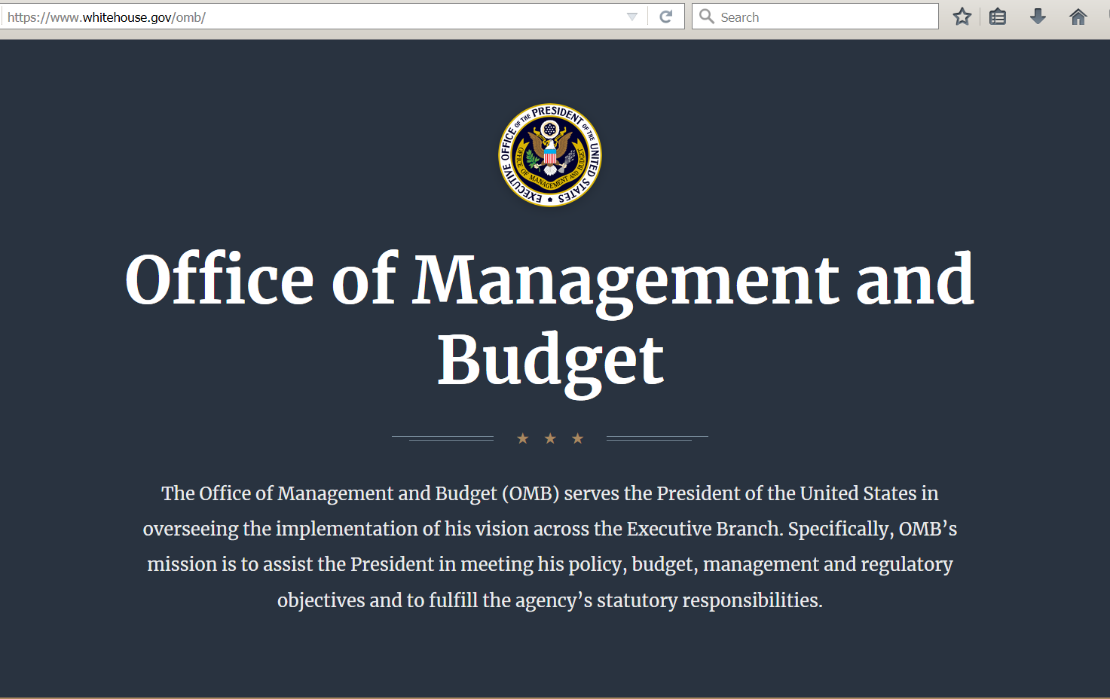

OMB carries out its mission through five critical processes that are essential to the President’s ability to plan and implement his priorities across the Executive Branch:

- Budget development and execution.
- Management, including oversight of agency performance, human capital, Federal procurement, financial management, and information technology.
- Regulatory policy, including coordination and review of all significant Federal regulations by executive agencies.
- Legislative clearance and coordination.
- Executive Orders and Presidential Memoranda.

* * * * * * * * * * * *

EPA - United States Environmental Protection Agency
https://www.epa.gov/laws-regulations/summary-executive-order-12866-regulatory-planning-and-review

Summary of Executive Order 12866 - Regulatory Planning and Review

Quick Links

E.O. 12866, from the National Archives
E.O. 13563, from the National Archives

58 FR 51735; October 4, 1993

Executive Order (E.O.) 12866 - Regulatory Planning and Review - was issued by President William J. Clinton in 1993. It provides that significant regulatory actions be submitted for review to the Office of Information and Regulatory Affairs (OIRA) in the Office of Management and Budget (OMB). A "significant regulatory action," as defined by the E.O., generally is any regulatory action that is likely to result in a rule that may:

- Have an annual effect on the economy of $100 million or more or adversely affect in a material way the economy, a sector of the economy, productivity, competition, jobs, the environment, public health or safety, or State, local, or tribal governments or communities;

- Create a serious inconsistency or otherwise interfere with an action taken or planned by another agency;

- Materially alter the budgetary impact of entitlements, grants, user fees, or loan programs or the rights and obligations of recipients thereof; or

- Raise novel legal or policy issues arising out of legal mandates, the President's priorities, or the principles set forth in this Executive order.

After Federal Register publication of such an action, the E.O. provides that the federal agency promulgating the action and OMB make available to the public the documents exchanged between them during the review. The federal agency must identify any substantive changes between the draft submitted to OMB and the published rule and must identify those changes made at the suggestion or recommendation of OMB.

Executive Order 13563 - Improving Regulation and Regulatory Review

E.O. 13563 – Improving Regulation and Regulatory Review – was issued by President Barack H. Obama in 2011 (76 FR 3821; January 21, 2011). It reaffirms and amplifies the principles embodied in E.O. 12866 by encouraging agencies to coordinate their regulatory activities, and to consider regulatory approaches that reduce the burden of regulation while maintaining flexibility and freedom of choice for the public. It directs agencies to, where feasible and appropriate, seek the views of those likely to be affected by a proposed rulemaking before a notice of proposed rulemaking is issued. E.O 13563 requires agencies to quantify anticipated benefits and costs of proposed rulemakings as accurately as possible using the best available techniques, and to ensure that any scientific and technological information or processes used to support their regulatory actions are objective.

To the extent feasible and permitted by law, E.O. 13563 also directs agencies to provide timely online access to the rulemaking docket for proposed and final rules, along with any relevant scientific and technical findings, on regulations.gov, and to afford the public the opportunity to comment on proposed regulations through the Internet. With regard to existing regulations, E.O. 13563 instructs agencies to periodically review their significant regulations with the goal of making their regulatory programs more effective or less burdensome.

More Information

More information is available from the Office of Management and Budget on regulatory matters for federal agencies.

